Phoenix Gymnastics Club - 2025

Cookie Dough - $25 Cheesecake - $25

- 2.7 lb Pail – 44 cookies
- Can be stored frozen or refrigerated
- See reverse side for flavor choices
- Easy to "scoops" and bake in 18 minutes.
- 2lb Gourmet Cheesecake
- 14 individually sliced pieces
- 3 Delicious flavours to choose from
- Easy last minute dessert.

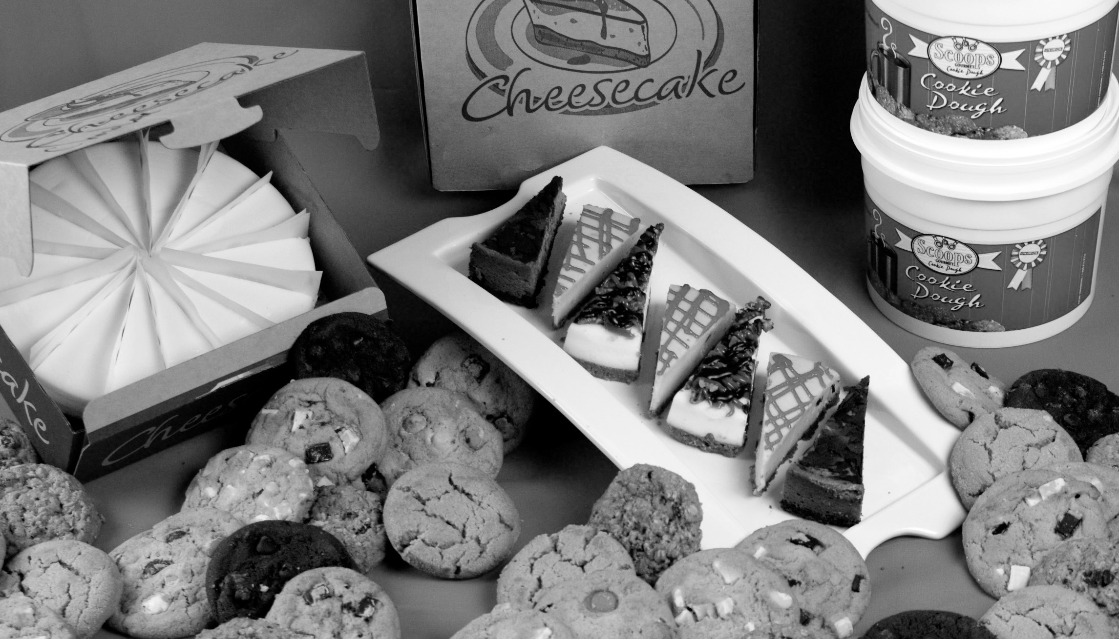






All cookie dough contain Milk, Wheat, Soy, Egg *Macadamia Nut May contain Tree nuts, Sulphites—PEANUT FREE. All cheesecakes contain Milk, Wheat, and Eggs. May contain Tree Nuts, Sulphites, and Soy. PEANUT FREE

Thank you for your participation and support!

1.877.767.9546

Sell 10 items
and receive a FREE
T-SHIRT!
T-Shirt Sizes
(Please check)
YOUTH:
XS S
M L XL
ADULT:
S M
L XL
Phoenix Gymnastics-2025
Contact: 780.438.0586 | phoenixgymnastics.info@gmail.com

 |  |  | Cookie Dough  $25.00 |  |  |  |  |  |  |  |  | Cheesecake  $25.00 |  |  |  |  | Total
 |  |  | Shortbread | White Chocolate Macadamia Nut | Monster (M&Ms) | Oatmeal Chocolate Chip | Double Chocolate | Ginger Molasses | Chocolate Chip | Oatmeal Raisin |  |  | New York Plain | Strawberry | Turtle |  | MONEY COLLECTED
Seller’s Name: Orders must be in by: Nov 1, 2025

Seller’s Phone:
Class Day: ORDER PICK UP:
NOVEMEBER 20, 2025
Class Time:

Customer’s Name Phone Number
1
2
3
4
5
6
7
8
9
10
11
12
13 | SELLERS CAN COLLECT OR | DERS ONLINE!
14 | GO TO www.futurefundraisin | g.com
15 | CLICK Seller Registration and fill out re | gistration form
16 | ONLINE ORGANIZATION CODE: | B3PGC
17 | Once registered, login to make a purchase | or copy and send your
18 | link to family & friends to coll | ect orders
19 | NOTE: Online orders must be pa | id by credit card
20
Top Sellers will Win PRIZES! |  |  |  |  |  |  |  | Tot | al Un | its


Please make cheques payable to: Phoenix Sports Foundation
2
1
3
4
5
6
7
8
9
10
Colour your way to a FREE T-Shirt

